# **Guide Line - Run Automation Test Scripts**

Before you can open the project on your computer, you must install:

* JDK 9.0 or higher:  
  <http://download.oracle.com/otn-pub/java/jdk/8u171-b11/512cd62ec5174c3487ac17c61aaa89e8/jdk-8u171-windows-x64.exe>
* Eclipse or IntelliJ as the IDE:  
  <https://www.eclipse.org/downloads/download.php?file=/oomph/epp/oxygen/R2/eclipse-inst-win64.exe&mirror_id=105>  
  <https://www.jetbrains.com/idea/download/download-thanks.html?platform=windows&code=IIC>
* Maven:  
  <https://maven.apache.org/>

**Open the Project:**

Your computer can access the internet first.

1. Download the Project:  
   Use any browser to download link:  
   <https://drive.google.com/drive/folders/1QWNIUjK7ZimM2ZrHRbGY8bZOR-O4jxN8?usp=sharing>
2. Download the React_App.zip and extract to your drive.
3. Open Eclipse or IntelliJ. In this case, I am using IntelliJ.
4. In menu top bar, select File -> Open…  
   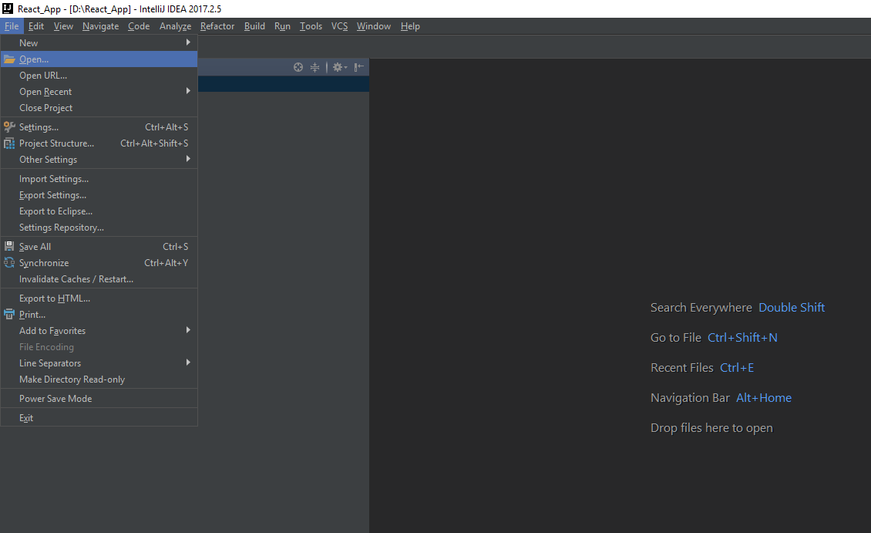
5. Browse to the folder which downloaded and select OK  
   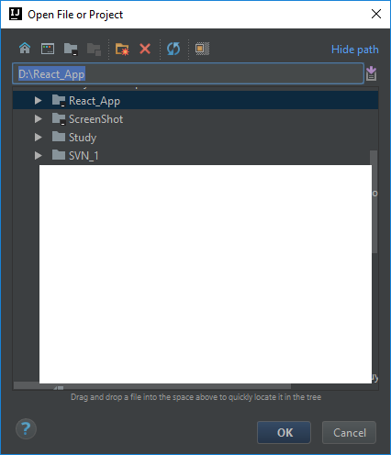
6. Select This Window  
   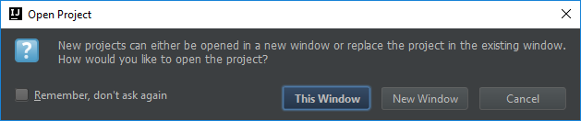
7. The structure of the project is displayed  
   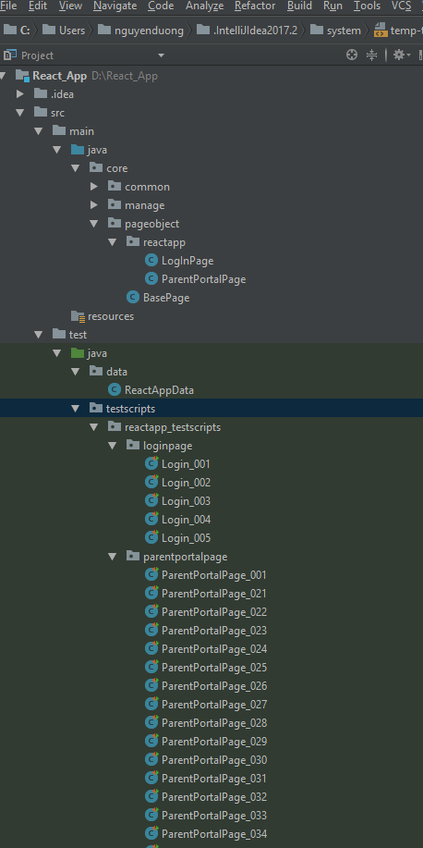
8. The software will be downloaded the library that needs. If the little popup in the left corner “Maven projects need to be imported” is displayed, select “Enable Auto-Import”. And please wait about 5 minutes.  
   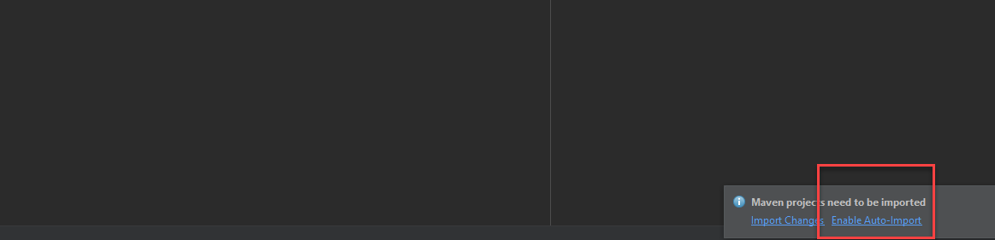
9. In package test/java/ testscripts, right click and select Rebuild ‘testscripts. And please wait a minute.  
   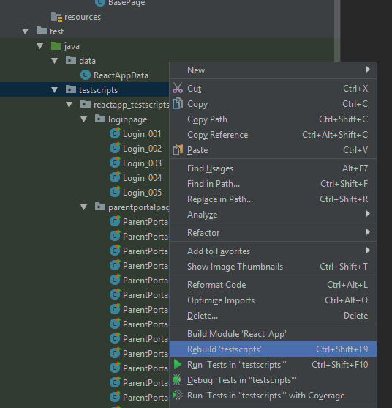
10. In folder test/java/ testscripts, right click and select Run -> Tests in “testscripts”  
    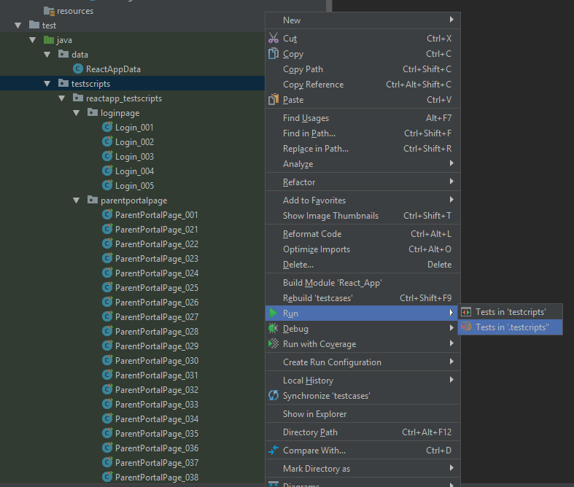
11. The IDE will start. All test cases which were defined in the package test/java/testscripts will be executed automatically.  
    In case an error popup “Cannot start process, the working directory ‘%MODULE_WORKING_DIR%’ does not exist.” is displayed. Please open the project folder (React_App) and deleted the folder “.idea”. Re-run step 9 again.  
    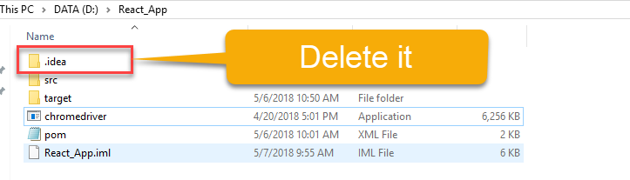
12. If you want to stop the progress, you can select the square button  
    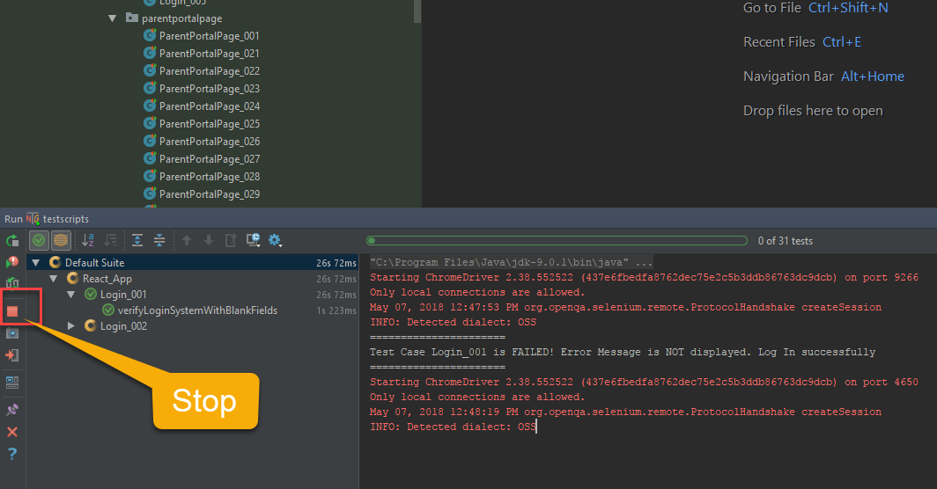
13. The report of the project is shown in the little window at the bottom of the IDE.  
    